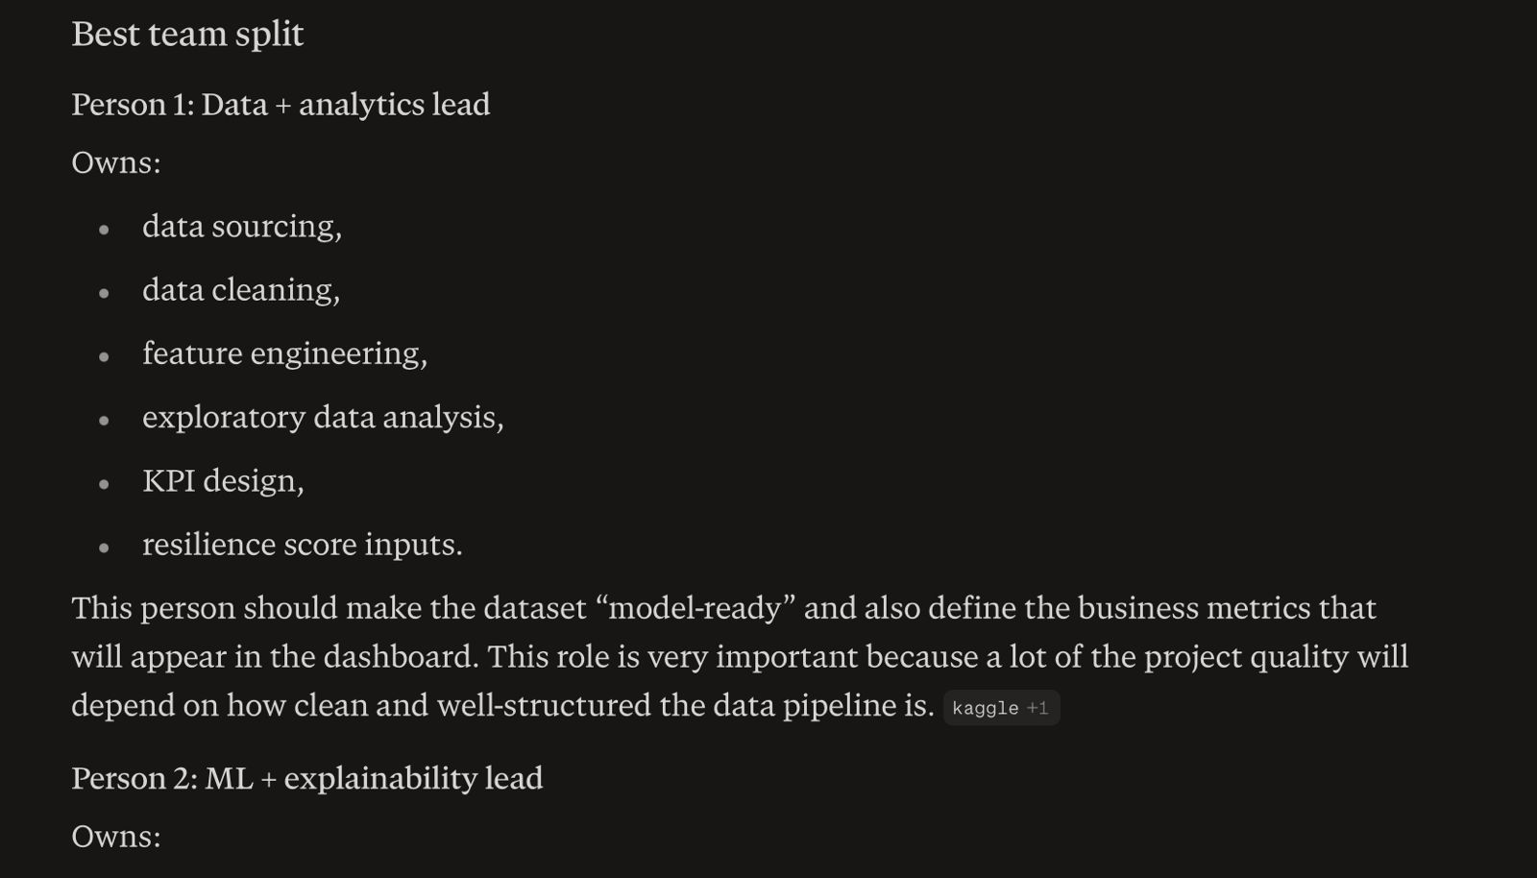
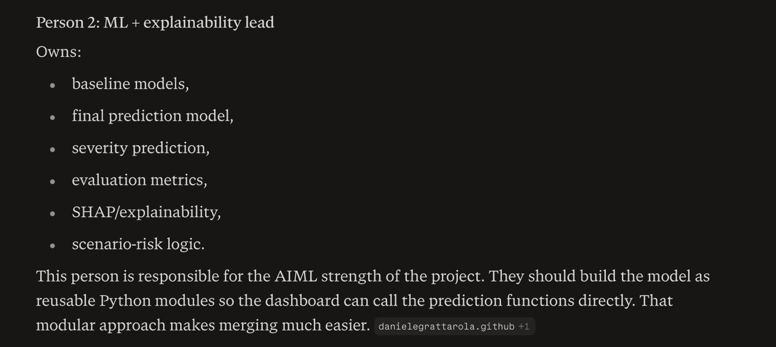
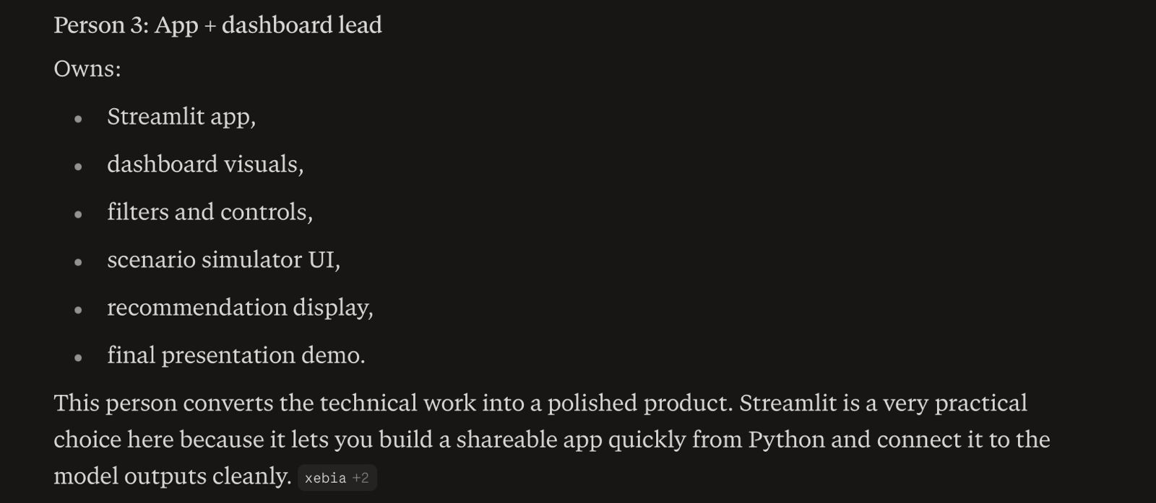
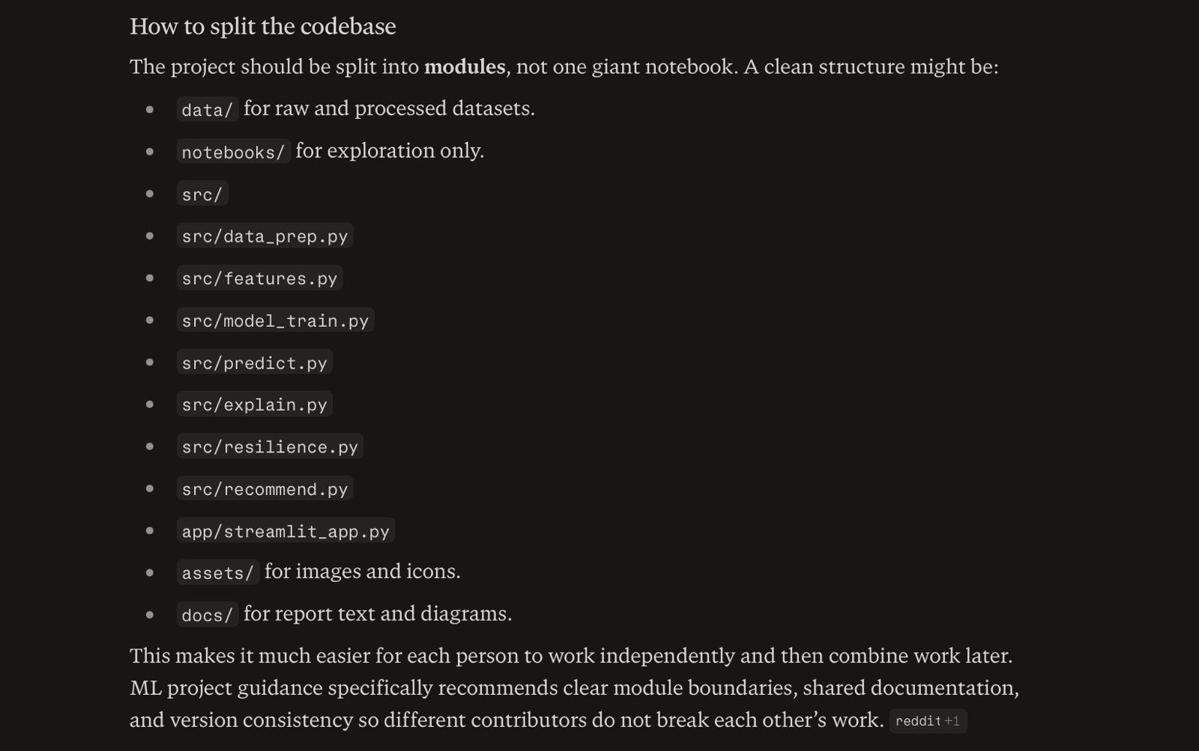
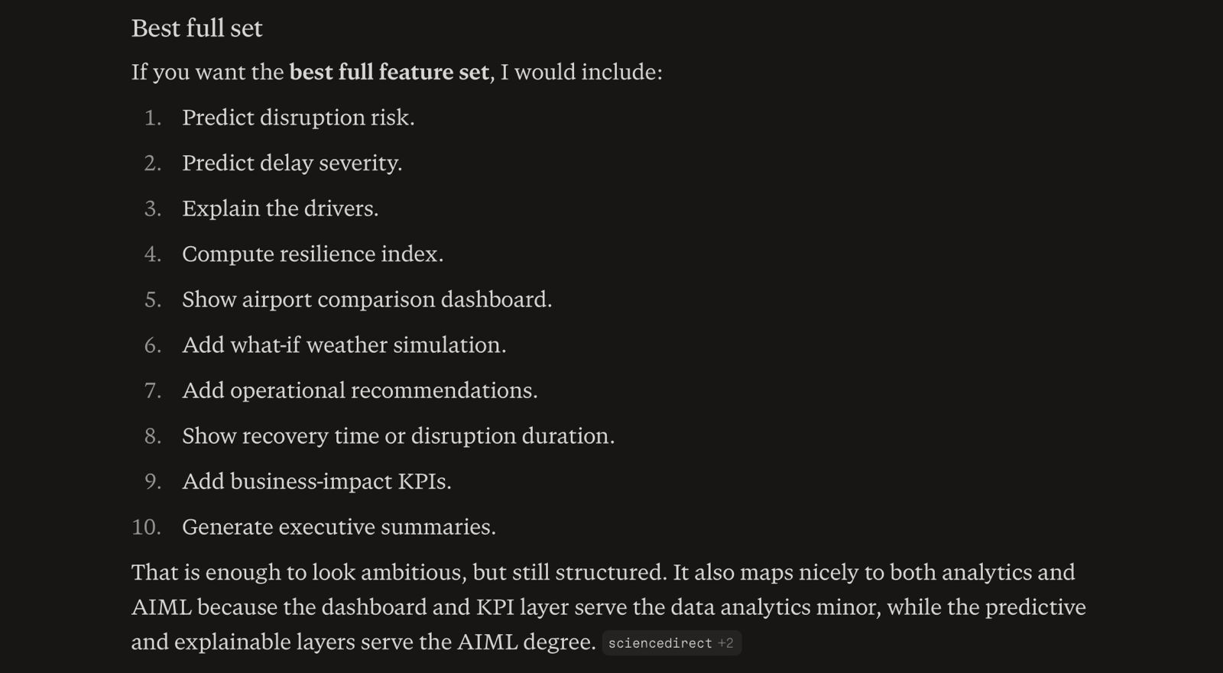
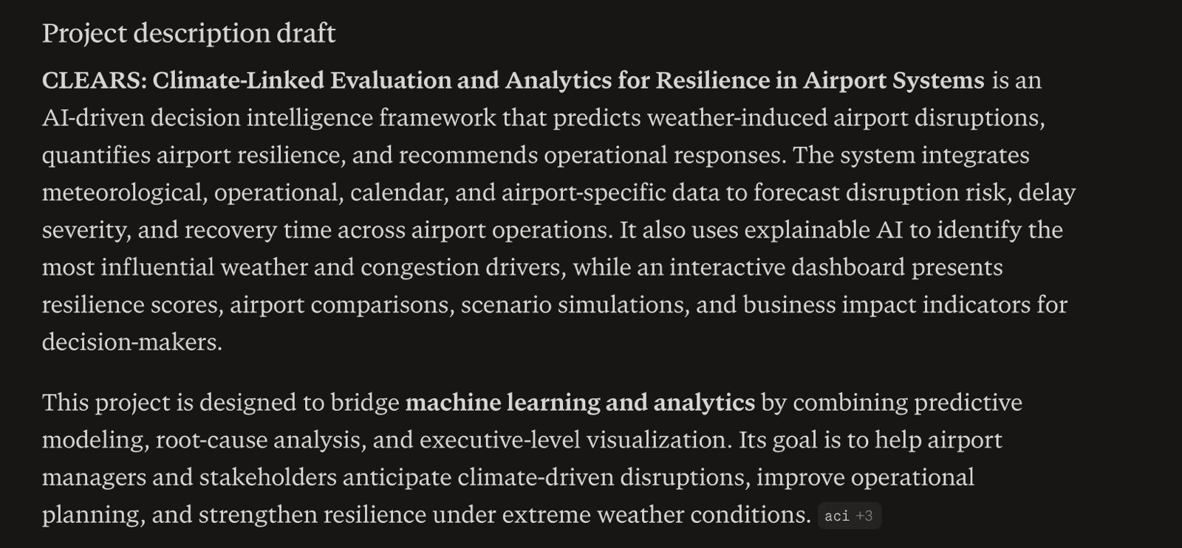
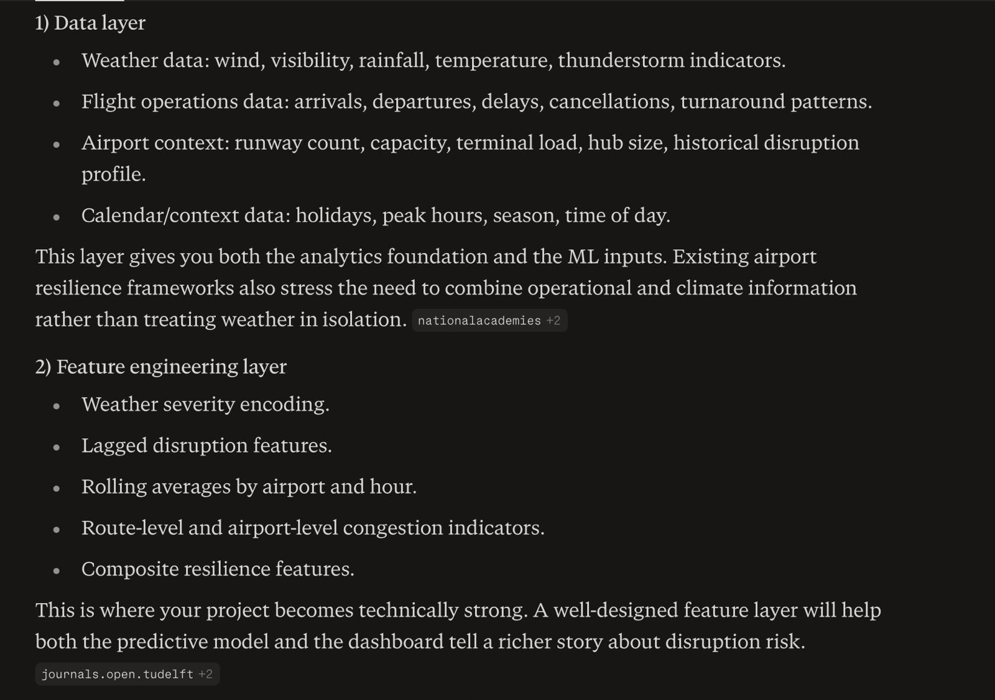
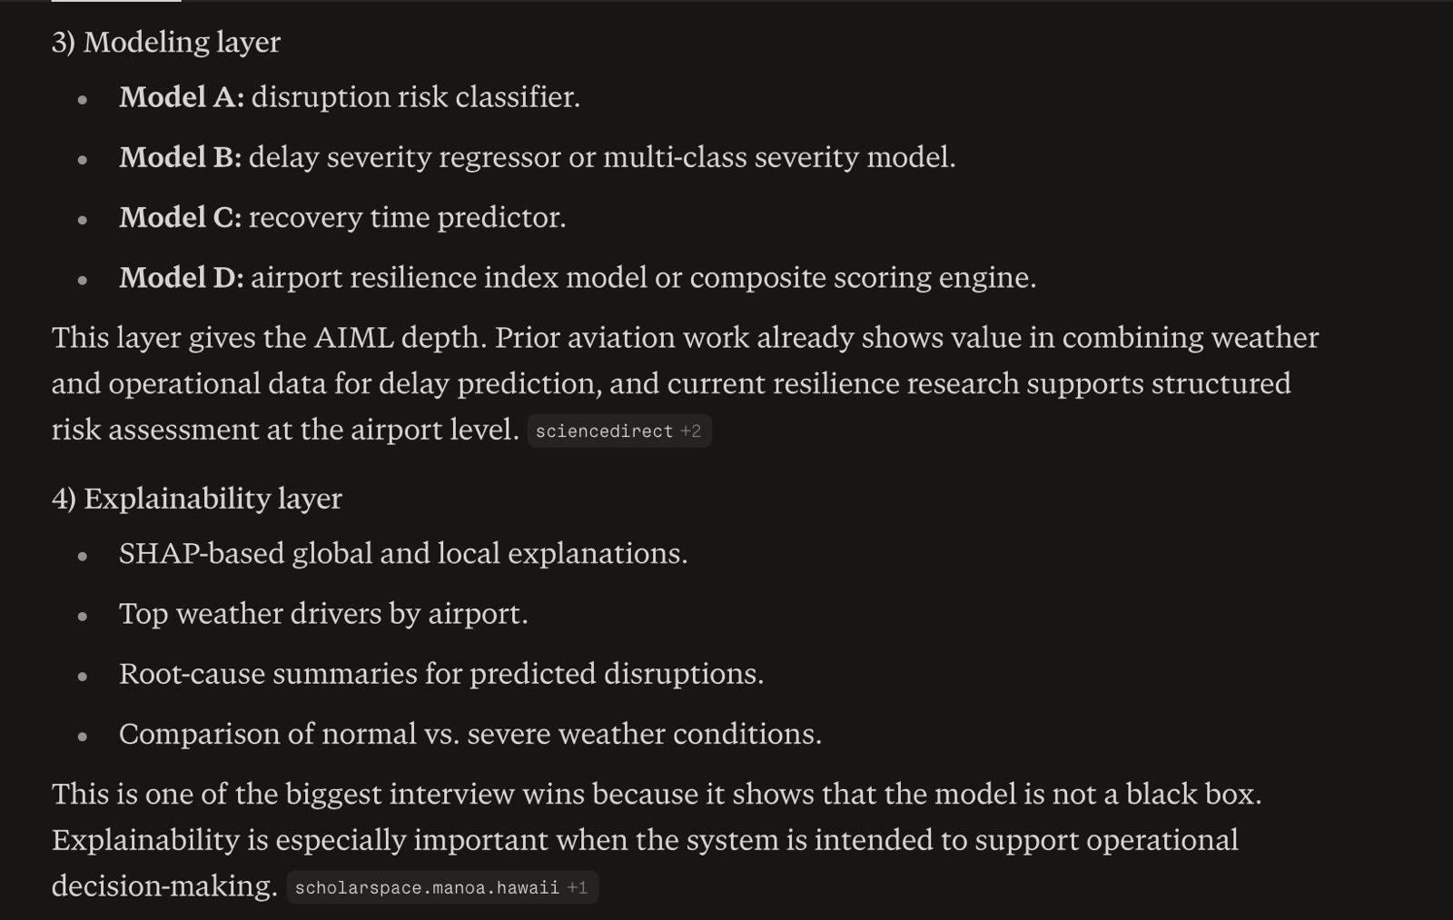
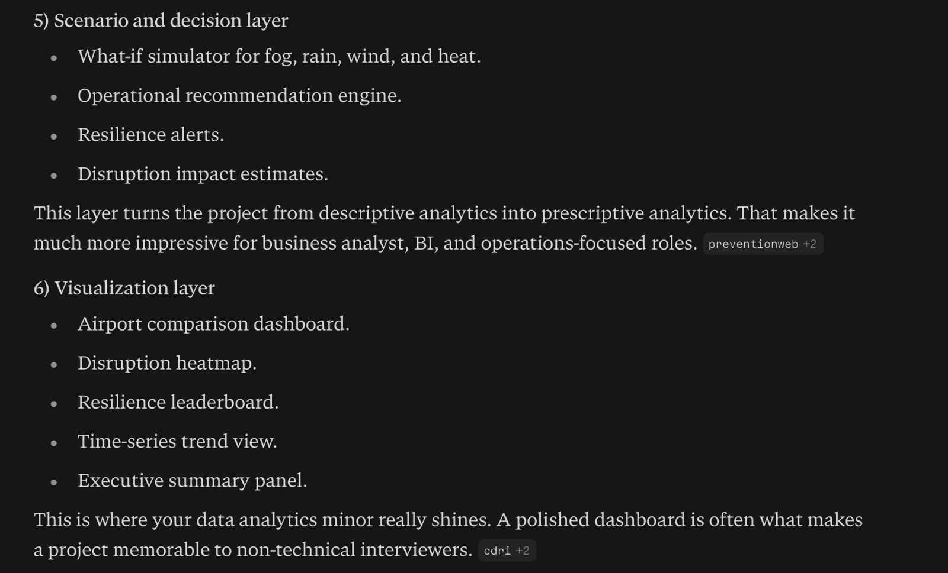
Project Overview
CLEARS: Climate-Linked Evaluation and Analytics for Resilience in Airport Systems is a smart airport operations and climate-resilience project that uses machine learning, data analytics, and explainable AI to predict weather-driven disruptions in airport operations and convert those predictions into actionable insights. The project is not just about forecasting delays. It is about understanding how adverse weather affects airport performance, measuring how resilient different airports are, explaining why disruption is likely, and helping decision-makers respond in a practical way.

In simple terms, the project answers questions like:

Will bad weather cause a flight delay or airport disruption?

How severe will the disruption be?

Which weather factors are driving the risk?

Which airport is more vulnerable than others?

What should airport operations teams do about it?

How can this be shown in a dashboard so that both technical and non-technical users understand it?

That makes the project much more interesting than a basic prediction model because it combines prediction, interpretation, resilience scoring, scenario analysis, and business-style decision support.

What Problem It Solves
Airports are highly sensitive to weather. Fog, heavy rain, storms, strong wind, heat waves, poor visibility, and turbulence-related conditions can all cause delays, cancellations, stand changes, gate congestion, runway restrictions, and operational bottlenecks. The problem is not only that delays happen, but that airport teams often need to make decisions before disruption becomes visible.

This project tries to solve that by creating a data-driven framework that can:

predict disruptions before they happen,

identify the level of risk,

explain the main causes,

estimate how resilient the airport is,

and support better operational planning.

That means the project is useful for airport managers, airline operations teams, business analysts, BI professionals, and anyone interested in AI-powered decision-making.

Core Idea
The project is built around one central idea:

Use weather and airport operational data to predict disruption, explain it, score resilience, and support response decisions.

This is important because many projects stop at prediction. But real operational value comes when prediction is connected to explanation and action. A model that says “delay likely” is helpful. A model that says “delay likely because visibility is low, wind is high, and this airport historically recovers slowly, so operations should adjust staffing and buffers” is much more impressive.

That is what makes CLEARS feel like a complete system rather than a standalone ML experiment.

What the Project Does End-to-End
The project can be understood as a pipeline with several layers.

1. Data Collection Layer
The first thing the system does is gather data from multiple sources. These can include:

weather information,

flight departure and arrival data,

airport metadata,

time-based context such as hour, day, season, and holidays,

and operational history such as prior delays or congestion patterns.

The reason this matters is that weather alone is not enough. A rain event at one airport may cause a minor delay, while the same event at a busier airport with fewer runways may cause a major disruption. So the system needs both climate data and airport-operations data.

This layer is the foundation of the entire project. Without good input data, the rest of the pipeline becomes weak.

2. Data Cleaning and Preparation
Raw data is almost always messy. It may contain missing values, inconsistent timestamps, duplicate records, categorical fields, and different measurement formats. So the project cleans the data before modeling.

This step includes things like:

handling missing weather values,

converting timestamps to usable formats,

standardizing airport codes,

creating consistent labels for delay or disruption,

filtering irrelevant records,

and removing noise.

This is a very important part of the project because cleaning determines whether the model will learn meaningful patterns or random noise. In analytics projects, this stage often takes more work than the modeling itself.

3. Feature Engineering
This is one of the most important parts of the project because it transforms raw inputs into useful signals for the model.

The system may create features such as:

wind intensity categories,

rainfall severity,

visibility thresholds,

temperature stress,

storm indicators,

delay history in the last 1 hour / 3 hours / 24 hours,

airport congestion levels,

rolling averages of disruption,

and seasonal or peak-hour signals.

The reason feature engineering matters is that machine learning models perform better when the information is shaped into patterns they can use. For example, a raw weather value might not mean much by itself, but a combination of “low visibility + peak traffic hour + high prior congestion” can strongly indicate risk.

This layer is also where the project becomes more intelligent than a simple spreadsheet report. It starts turning data into operational insight.

4. Disruption Prediction Model
The main ML layer predicts whether a weather event or operational condition will cause disruption.

This can be framed in different ways:

binary classification: disruption vs no disruption,

multi-class classification: low, medium, high disruption,

or regression: predict delay minutes or disruption duration.

The model could be XGBoost, LightGBM, random forest, or another structured-data model. These usually work well for airport-style tabular data.

This model answers the question:
“What is likely to happen?”

That makes it the analytical core of the project.

5. Delay Severity Estimation
Instead of stopping at a yes/no prediction, the project goes further and estimates severity. This is important because not all disruptions are equal. A five-minute delay and a two-hour disruption are very different business problems.

Severity prediction can help the system show:

minor disruption,

moderate disruption,

severe disruption,

or very severe operational impact.

This makes the project more valuable because it supports prioritization. Airport teams care not only about whether a delay occurs, but how bad it will be and how quickly they need to act.

6. Explainability Layer
This layer explains why the model made a prediction.

Using explainability methods, the system can show:

which weather variables mattered most,

which operational factors contributed to risk,

whether visibility, wind, rainfall, or time-of-day had the biggest effect,

and how a specific airport’s profile influenced the outcome.

This is critical for trust. In real operational settings, users do not want a black box. They want to understand the logic behind the result.

This also makes the project much more impressive in interviews. You can say not only “I trained a model,” but also “I made it interpretable so operations teams can trust the recommendation.”

7. Resilience Index
This is one of the most unique parts of the project.

Instead of only predicting delay, the system calculates a resilience score for each airport or time period. This score reflects how well an airport handles weather stress.

A resilience index may consider things like:

frequency of past disruptions,

average recovery time,

weather vulnerability,

congestion sensitivity,

and operational robustness.

The purpose of this index is to answer:
“How resilient is this airport under weather stress?”

This is a powerful idea because it moves the project from event prediction into strategic evaluation. It can help compare airports, identify weak spots, and support long-term planning.

8. Scenario Simulation
This layer lets users test “what if” situations.

For example:

What if visibility drops below a threshold?

What if wind speed increases sharply?

What if heavy rain occurs during peak traffic?

What if temperature and humidity combine to create high operational stress?

The system can then show how predicted disruption risk changes.

This makes the project highly interactive and very impressive because it behaves like a decision lab rather than just a prediction engine. It gives users a way to explore different future conditions.

9. Recommendation Engine
After predicting risk and explaining it, the system suggests operational actions.

Examples include:

add staffing buffers,

delay departures proactively,

hold gate assignments,

reallocate resources,

send alerts,

or prepare recovery operations.

This is where the project becomes prescriptive rather than descriptive. It does not just say what might happen. It suggests what to do.

For a business analyst or operations-oriented role, this is extremely valuable because it shows practical thinking, not just modeling.

10. Dashboard and Visualization
The final layer is the visual interface. This is what makes the project accessible and presentable.

The dashboard can include:

airport risk heatmaps,

trend charts of delays,

resilience rankings,

weather-risk correlation plots,

scenario comparison panels,

and operational summary cards.

This is important because not everyone who sees your project will be technical. A dashboard helps recruiters, professors, and interviewers immediately understand the value.

This is also where the data analytics minor becomes very visible. A strong dashboard shows reporting, storytelling, KPI design, and business communication.

Why Each Part Exists
Every part of the project serves a different purpose:

Data layer gives the raw facts.

Cleaning layer makes the facts usable.

Feature engineering turns facts into signals.

Prediction model estimates what may happen.

Severity model tells how bad it will be.

Explainability tells why it happened.

Resilience score tells how strong or vulnerable the airport is.

Scenario analysis lets users explore possibilities.

Recommendation engine turns insight into action.

Dashboard communicates the result.

So the project is designed as a full decision-support system, not just an ML experiment.

Why It Is Strong for AIML
This project is excellent for AIML because it shows:

data preprocessing,

supervised learning,

feature engineering,

model evaluation,

interpretability,

and applied problem-solving.

It proves you can build an end-to-end AI system on structured data. That is the kind of thing many recruiters like to see because it reflects practical ML skill, not just theoretical knowledge.

Why It Is Strong for Data Analytics
This project is also excellent for a data analytics minor because it shows:

KPI design,

business interpretation,

dashboarding,

scenario analysis,

trend analysis,

and operational storytelling.

That means it can fit both technical and business-facing roles.

Why It Feels Unique
The project is unique because it combines several ideas that are usually separated:

delay prediction,

climate resilience,

airport scoring,

explainable AI,

and operational decision support.

Most projects only do one or two of these. Combining them into one coherent framework makes it much more memorable.

Final Mental Model
Think of the project as a smart airport resilience assistant.

It watches weather and airport operations, predicts disruption, explains the reason, scores the airport’s resilience, simulates future scenarios, and suggests what operations teams should do next. Then it presents everything in a clean dashboard.

That is why the project is strong: it is not just about prediction, but about understanding and acting on prediction.

